Netflix System design

Systems design implies a systematic approach to the design of a system. System Design is the process of designing the architecture, components, and interfaces for a system so that it meets the end-user requirements.

Functional Requirements:
- Content upload (videos, shows)
- User streaming and interaction (like, dislike, share)
- Personalized video recommendations
Non-Functional Requirements:
- High availability with minimal latency
- Scalability and efficiency to handle millions of users
System Design Principles:
- Break down the problem into smaller components (services, features).
- Clearly define the system's goal and avoid overcomplication.
- Make reasonable assumptions about scale and usage (users, requests, data).
- Design data models and data flow between components.
- Employ high-level and low-level design approaches.
Assumptions:
- 1 billion users, 200 million daily active users
- 1 million videos, 1,000 new uploads daily
- 1 billion requests per day (12,000 per second)
Data Storage and Management:
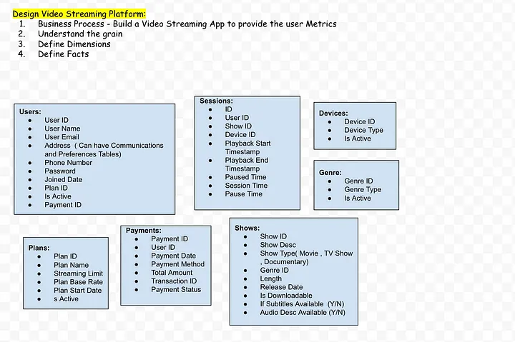
- User data (name, email, location, etc.)
- User interaction data (video history, ratings, etc.)
- Video data (ID, genre, cast, release year, stream URL, etc.)
- PostgreSQL for structured data (user, video)
- NoSQL database (Cassandra) for flexible schema (interactions)
- Data lake/warehouse (S3) for storing raw and preprocessed data

Horizontal Scaling | Vertical Scaling
When additional machines are added to the existing system to meet the higher expectation, it is known as horizontal scaling. | When new resources are added in the existing system (increasing RAM, CPU) to meet the expectation, it is known as vertical scaling
It is easier to upgrade. | It is harder to upgrade and may involve downtime.
It is difficult to implement | It is easy to implement
It is costlier, as new server racks comprise a lot of resources | It is cheaper as we need to just add new resources
Cassandra, MongoDB, Google Cloud Spanner | MySQL and Amazon RDS

Compute and Orchestration:
Today almost all of Netflix runs on VMs (virtual machines) in AWS. A customer's catalog browsing experience, content recommendation calculations, and payments are all served from AWS.
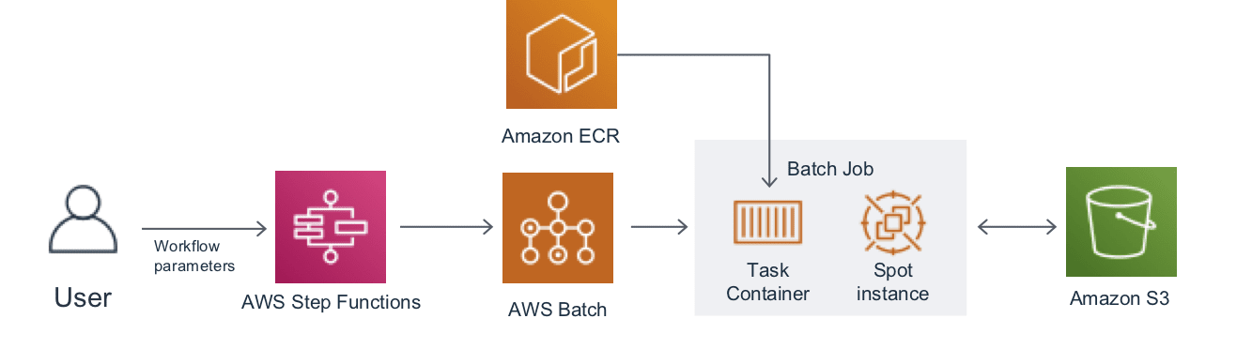
- Cloud-based infrastructure (AWS)
- EC2 virtual machines for core services
- AWS Step Functions and Batch for workflow automation and batch processing
- SageMaker notebooks for experimentation

Video Content Storage and Delivery:
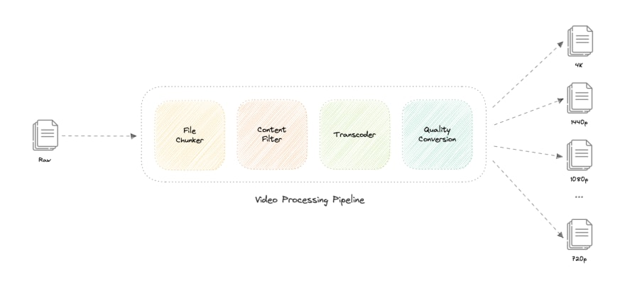
- Amazon S3 for scalable and highly available storage
- Pre-encoded videos in multiple formats and resolutions for different devices
- Content Delivery Network (CDN) for geographically distributed content caching (Open Connect program)
- Low latency and high availability through geographically dispersed content replicas
- 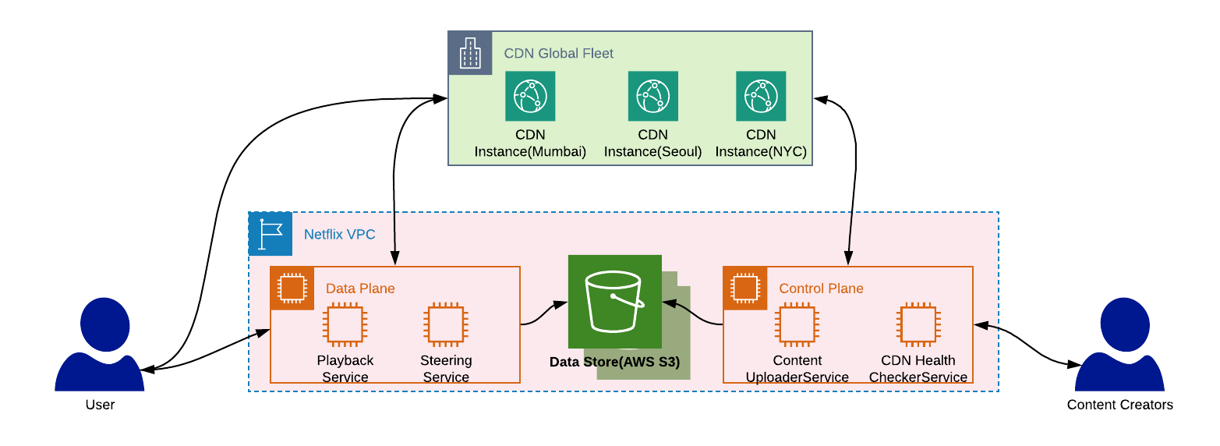
- 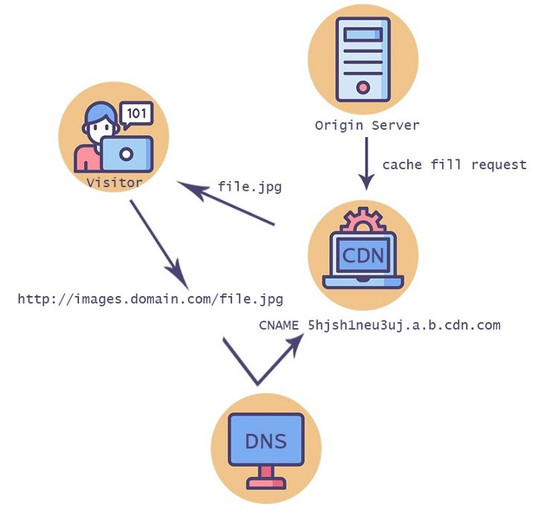
User Interactions and Recommendations:
- User interactions stored in NoSQL database for scalability and flexible schema
- Recommendation systems based on machine learning algorithms (collaborative filtering, content-based filtering, etc.)
- Personalized recommendations based on viewing history, ratings, device, time of day, etc.

To make our system more resilient we can do the following:

- Running multiple instances of each of our services.
- Introducing load balancers between clients, servers, databases, and cache servers.
- Using multiple read replicas for our databases.
- Multiple instances and replicas for our distributed cache.

